CRICKET CART BATTERY CARE, MAINTENANCE
& TROUBLESHOOTING GUIDE
The Cricket carts use a Sealed Lead Acid (SLA) series of batteries to power the current three models: RX5 |SX3 |ESV. The RX5 and SX3 models use 3x12 volt (36v) SLA batteries and the ESV older models (before 2023) use 2x12 volt (24v). ESV models starting in 2023 use 3x12v SLA batteries.
This guide is to get the most life possible out of your SLA batteries and how you know when it's time to replace them. ALWAYS REFER TO THE MANUFACTURES INSTRUCTIONS FOR SAFETY, USE AND MAINTENANCE.

What is an SLA Battery?
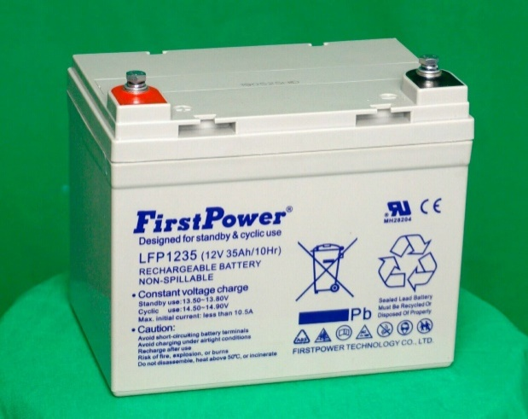
The primary difference between SLAs and other lead acid batteries is that they are sealed. This makes them completely leak-proof and without fear of them spilling. You DO NOT have to top them off with distilled water the way you do with traditional lead acid batteries. This is because the gas produced by an SLA battery is reabsorbed into the battery's electrolyte, eliminating the need for additional water.
Specifications: Nominal Voltage 12 V Capacity (25℃) 10HR(10.8V) 35 Ah 5HR(10.5V) 30.6Ah 1HR(9.60V) 21.7Ah
Dimension: Length 195±2mm (7.68inch) Width 130±1mm (5.12inch) Height 155±2mm (6.10inch) Total Height T7: 180±2mm (7.09inch) T9: 166±2mm (6.54inch) Approx. Weight 10.2kg (22.4lbs)±4%
Item shown may not match the actual battery in your Cricket. We reserve the right substitute it for a matching product from another manufacture.

How Long Does an SLA Battery Last?
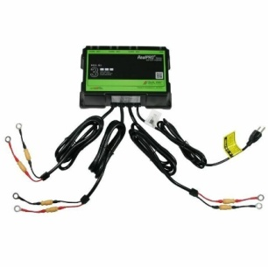
The life of an SLA battery will depend on several factors, the two most impacting is the operating temperature and how well it's been maintained. Battery life is measured in charging cycles. A single charging cycle refers to the process of going from the battery's full charge capacity to a >50% discharge. You can expect an SLA batteryin your new Cricket to last 450 and 500 charging cycles.The batteries are designed with a life capacity of approximately 5 years. This DOES NOT mean your batteries will last this long.
How Do You Maintain an SLA Battery?

Obviously, you're going to want to get the longest life possible out of your batteries. Accomplishing that depends largely on your charging habits.

The best manner to maintaing a long battery life is to use your Cricketregularly (daily or weekly) and charge after every use. Never leave your batteries stored depleted of charge and, when not used regularly, NEVER let your batteries sit without charging more than two weeks.
Your Cricket comes with a properly designed “Intelligent” marine grade chargerrated specifically for the Cricket SLA batteries. The RealPRO ™ Series Battery Charger is a dependable, rugged construction and waterproof unit. This charger has an automatic “Battery Maintenance Mode” to avoid overcharging.
The charging mode on the RealPro™will be indicated by a RED light on one or more of the battery light indicators on the top of the charger. Be sure all lights are GREEN before unplugging. GREEN indicates full charge.
See User Manual (https://www.dualpro.com/) for charger use, care, safety and support. Use of an improper charging practice may cause injury, fire, damage, death or void warranty.
As long as the charger is attached to AC power, each charging bank will remain in a “float” stage once the battery is charged and then monitor and/or maintain the battery indefinitely.DO NOT CHARGE FOR MORE THAN 72HOURS (3 DAYS).
If you are not using and recharging your batteries regularly (daily or weekly), we recommend placing your RealPro™ charger on a proper weekly timer set to charge every two weeks for 8 to 10 hours. Be sure to comply with all electrical codes and user manuals.
Do not attempt to speed up the charging time or increase the voltage in an attempt to charge your batteries faster. Improper charging leads to overheating, which can kill your battery completely in as little as a few hours. If your battery is looking swollen or cracked or you find a buildup of corrosion on its terminals that's one sign that it's been overcharged.
Undercharging is equally problematic. When a battery is undercharged it has to work much harder than a fully charged one, resulting in a shortened battery life. CHARGE BATTERIES TO FULL LOAD AFTER EVERY USE.

SLA Battery Charging & Storage Tips
Follow these suggestions to maintain a regular charge and keep your SLA battery healthy.
- Recharge your batteries to a FULL (green) state after each use.
- Keep the front seat cover of your Cricket in the UP position. The Charger disburses a small amount of ‘warm’ temperature heat. If the Charger is ‘hot’ to the touch, unplug immediately and call your dealer.
- Do not let the batteries go without charging to the ‘Full Charge Mode” more than 2 weeks. Be sure the charger shows all GREEN as shown in the below Eg: 2 image.
____________________________________________________

CHARGER STATUS EXAMPLE

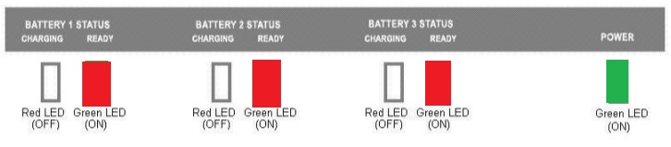
Eg:1

Charger lights will be RED – Indicating Batteries are in “Charging Mode”

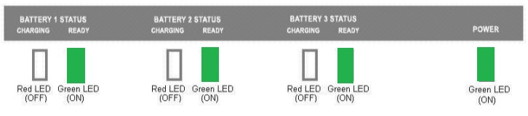
Eg:2

Charger lights will be GREEN– Indicating Batteries are “Full Charge Mode”
_______________________________________________
Once FullyCharged, do one of the following:
  - Disconnect the charger,or
  - Connect to a weekly timer set to charge for 8 to 10 hours every 14 days.
DO NOT KEEP YOUR BATTERIES CHARGING FOR MORE THAN 72 HOURS (3 DAYS).
- When storing an SLA battery, be sure to keep it in a cool, dry place.
- Again, DO NOT store an SLA battery in a discharged state.
Lead acid batteries will self-discharge 5% to 15% per month, depending on the temperature of the storage conditions.

Signs That Your SLA Battery is Dying
Even with the proper care and storage, your SLA battery will eventually need to be replaced. If your battery is having trouble holding a charge, you'll want to have it “LOAD” tested to measure the health of each battery.
If you notice corrosion on the terminal, clean off using a wire brush. Swollen batteries, however, have already been damaged and will need to be replaced and should not be used as they could cause damage to your Cricket.

Accessing Your SLA Batteries and Troubleshooting
- Make sure your Cricket is turned OFF
- Lift and remove the front bench seat from the Cricket
- Remove the floorboard (RX5 and SX3)
- Remove the two screws on each side of the Battery Charger Box. Lift the Charger boxand carefully set on top of the Controller (driver side). TIP: Place a towel under the box to not scratch the Controller cover)
- Check all that all cable terminals are intact and tight.
- Check for any corrosion. If corrosion is present, clean off any corrosion and you may need to replace the batteries.
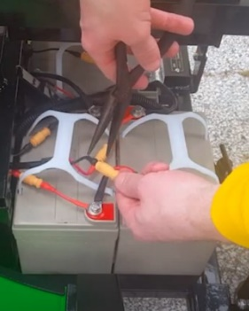
- Check all fuses in the cable lines. Use pliers and be careful not to crush the 30-amp glass fuse. (See Image)
- Plug in the charger and confirm each battery status lights turn on (Green or Red) all light up.
  - If all charging indicator lights do not turn on (Green or Red), DO NOT OPERATE YOUR CRICKET and:
  - Call the number or QR Code on the top of the Charger to troubleshoot Charger issues with the manufacturer.
- You may want to perform a BATTERY ‘LOAD’ TESTat this time to determine the overall health of yourbatteries. Load testing is not“battery testing” and requires a special testing device that most auto parts stores or battery shops will perform for you. If any of the batteries are showing low performance readings, we suggest replacing all the batteries.
- If the batteries are depleting faster than you expect, make sure the REMOTE TRANSMITTER SWITCH is Off. (“O” is pressed down) (see image)

CRICKET CARTS DIRECT, LLC

492 Atlantis Road | Unit 8 | Melbourne | FL | 32904

Contact@CricketCartsDirect.com |(321) 306-6007 | www.CricketCartsDirect.com

All Rights Reserved

