Cricket Cart Direct, LLC.
Remote Control

Installation Instructions and Wiring Diagram
for RX5 and SX3 (36V)

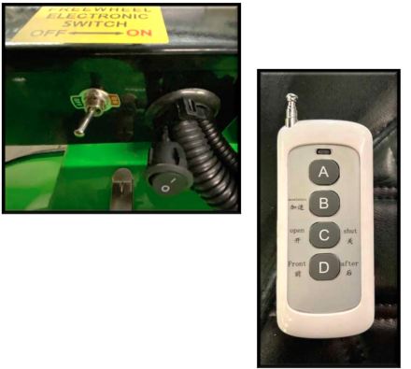
1. Set the Remote Control Enable Switch to “ON”. Located under the Front seat near the Electric Brake Release Switch.
2. Check that the Electronic Brake Switch is set to “Off”.
3. Check the Key Switch and make sure it is in the “OFF” position.
4. Set the Forward / Reverse Switch on the Dash to “Forward”
5. Using the Remote press “C” to turn the Cart “ON”. You will see the battery meter light come on.
6. Using the Remote press “D” to select Forward or Reverse. When Reverse is active you will hear the Cart beep. Press “D” again to place the Cart in Forward. The Reverse beeper will turn off.
7. Using the Remote press “ B” to engage the pre-set throttle and move the Cart. Stop pressing “B” to stop the Cart’s movement.
8. Once you are done loading or unloading the cart press “C” to turn off the Remote Control system.
9. Set the Remote Control Enable Switch to “OFF”.
____________________________________________
Cricket Remote Control Installation

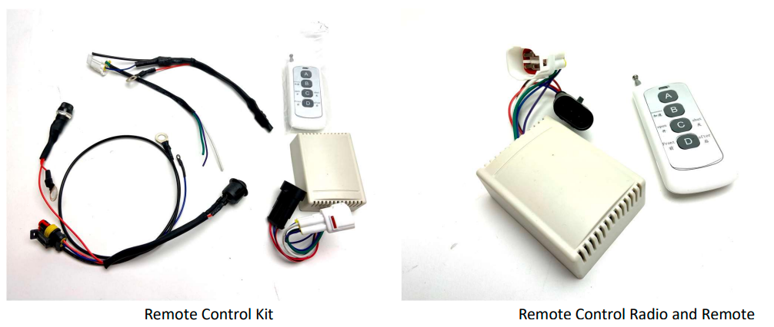

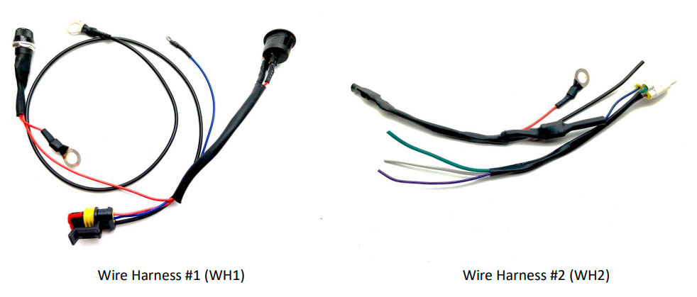
____________________________________________

Cricket Remote Control Installation Wiring Instructions

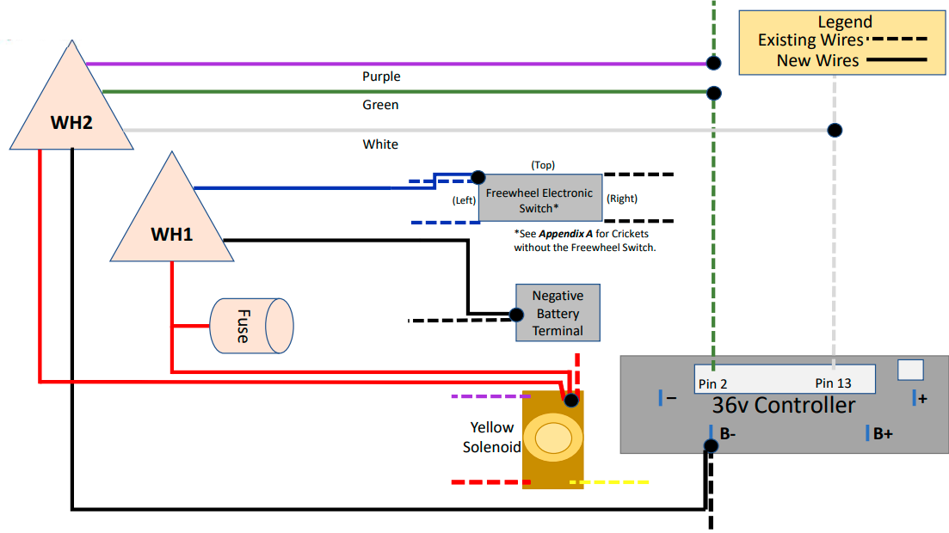

____________________________________________
Step-By-Step Instructions

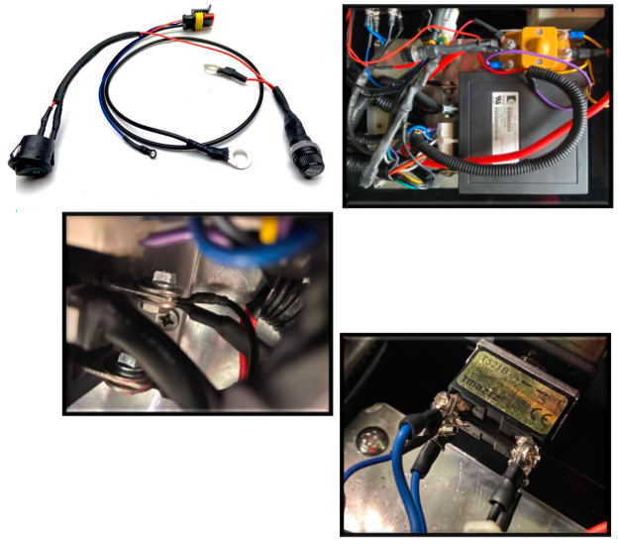
1. Remove the Controller Tray Cover.
2. Inside the Controller Tray Remove the U-Shaped brackets holding the wire harnesses in place.
3. At the Controller locate the Black cable shown in the diagram and disconnect it from the Controller.
4. Connect the Blue cable from WH1 to the Freewheel Electronic Switch as shown in the diagram. Cricket Carts that do not have this switch see Appendix A
5. Route the Black cable with a lug from the WH1 and connect it to the Negative Battery Terminal on the driver’s side battery.
CAUTION: Be careful using a wrench on the battery terminal not to touch the other exposed terminals. Serious damage to the golf cart or personal injury could result in shorting the battery terminals.
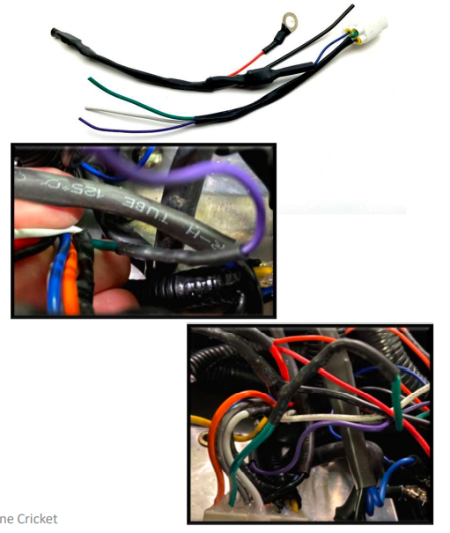
6. At the Controller locate the Green and White cables on the 16 Pin white connector on the Controller. See Diagram for pin callout.
7. Using wire cutters cut the Green cable approximately 3.5 inches from the white connector. You will splice cables from WH2 to these cables. (Step 10 and 11)
8. Approximately 3.5 inches from the White connector carefully remove approx. ¼ inch of insulation from the White cable.
9. Strip the wire insulation off the end of for the (4) wires cables on WH2 to reveal at least ¼ of exposed wire.
10. Splice the Purple cable on WH2 to the Cart end of the Green cable you cut in Step 11.
11. Splice the Green cable on WH2 to the Controller end of the Green cable you cut in Step 11.
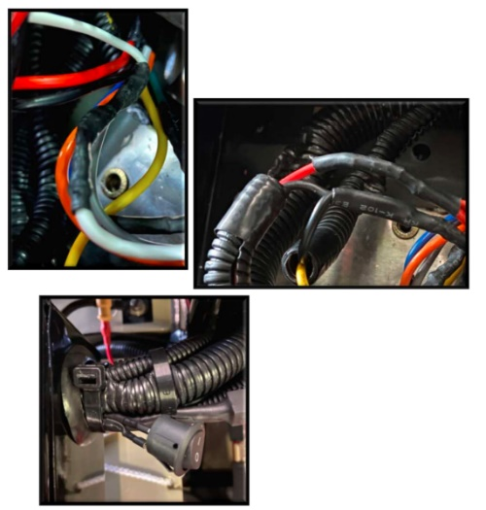
12. Connect the White cable from WH2 to the area where you removed the insulation from the White cable in Step 8.
13. Connect the Red cables from WH1 and WH2 to the Yellow Solenoid per the wiring diagram.
14. Disconnect the Remote Control Enable Switch. Mark on one of the Red cables so you can connect it back the same way. Then route the cables through the access hole on the back of the Controller Tray.
15. Connect the Remote Control Enable Switch making note of the cable you marked so it’s connected the same way.
16. Connect the Black wire from WH2 and the Black wire removed from the Controller back to the negative terminal per the wiring diagram.

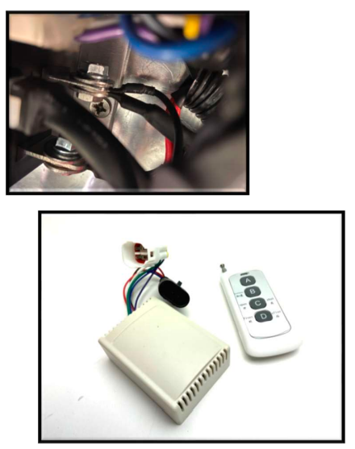
17. Connect the Remote Control Radio to the connectors on WH1 and WH2. Place the Radio next to the Controller inside the tray.
18. Turn the Key to “OFF”, set the direction switch on the dash to Forward and set the Remote Control Enable Switch to “On”.
19. Press the “C” button on the Remote Control to activate the Remote Control System. You should see the battery meter light on the dash come “On”.
20. Press the “B” button on the Remote Control and your cart should start to slowly move forward.
21. Replace U-Shaped brackets removed in Step 4.
22. Replace the Controller Tray Cover.
____________________________________________

Appendix A

NOTE: For Older Cricket Carts that DO NOT have the Freewheel Electronic Brake release switch follow these steps.

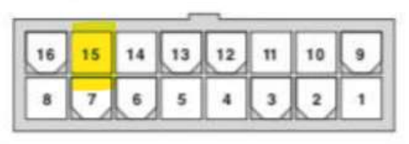
A. Locate the Blue cable going to pin 15 on the sixteen-pin connector going to the controller.
B. Approximately 3.5 inches from the connector carefully remove approx. ¼ inch of insulation from the Blue cable.
C. Cut the lug and strip the wire insulation off the end of for the Blue wire on WH1 to reveal at least ¼ of exposed wire.
D. Splice the Blue cable from WH1 to the Blue cable you removed the insulation from in Step B.
E. Return to Step 5 in the main Instruction.

692 Atlantis Road, Unit 8
Melbourne, FL 32904
Contact@CricketCartsDirect.com

